|  |  |  |  |  |  |  |  |  |
| --- | --- | --- | --- | --- | --- | --- | --- | --- |
| Forecast Values | |  |  |  | Compiler Engine Information | | |  |
|  |  |  |  |  |  |  |  |  |
| Stand ID: | | 1379036 | | | GYPSY Model: | | 2009-May-21 | |
| Stand Type: | | Natural |  |  | Application: | | 20100713p | |
| Stand Age: | | 156 | years |  | COM DLL: | | 20100329b35 | |
| Spatial: | | NO |  |  |  |  |  |  |
| BA adjusted: | | YES |  |  |  |  |  |  |
|  |  |  |  |  |  |  |  |  |
| Input Data | |  |  |  |  |  |  |  |
|  |  |  |  |  |  |  |  |  |
| Species | | totage | topht | den | ps | ba | utilization | |
| AW |  | 156.0 | 22.28 | 133 |  | 7.94 | 13/7/30 | |
| SB |  |  |  |  |  |  | 15/10/30 | |
| SW |  | 102.0 | 22.28 | 125 |  | 7.45 | 13/7/30 | |
| PL |  | 145.0 | 22.28 | 577 |  | 34.27 | 13/7/30 | |
|  |  |  |  |  |  |  |  |  |
| Calculated Attributes | | |  |  |  |  |  |  |
|  |  |  |  |  |  |  |  |  |
| Species | | bhage | y2bh | si_bh | si_t | n0 | sdf | psi |
| AW |  | 150.5 | 5.5 | 12.2 | 11.3 | 784 | 507 |  |
| SB |  |  |  |  |  |  |  |  |
| SW |  | 92.7 | 9.3 | 14.8 | 12.7 | 128 | 127 |  |
| PL |  | 136.9 | 8.1 | 14.5 | 13.0 | 8,377 | 2,907 |  |

Tesera Gypsy

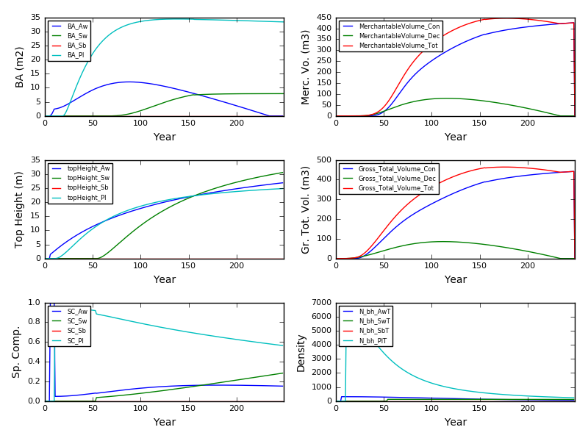

Excel Gypsy

